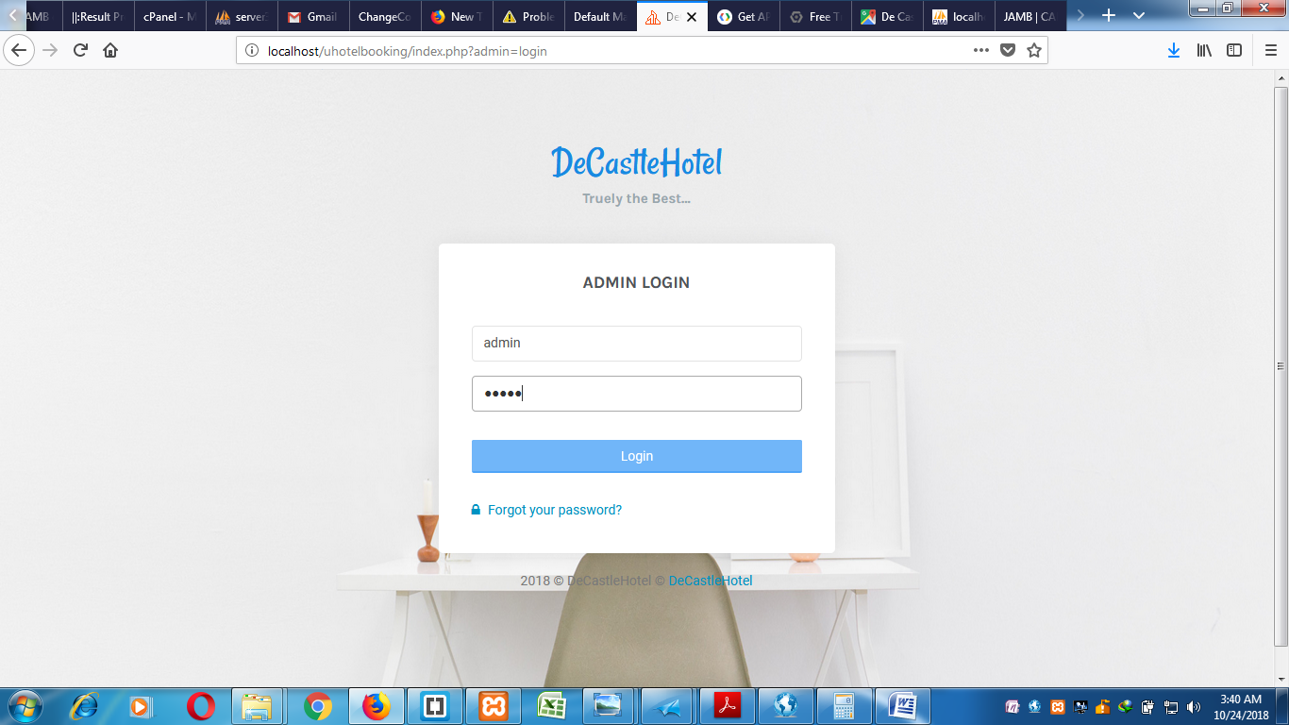

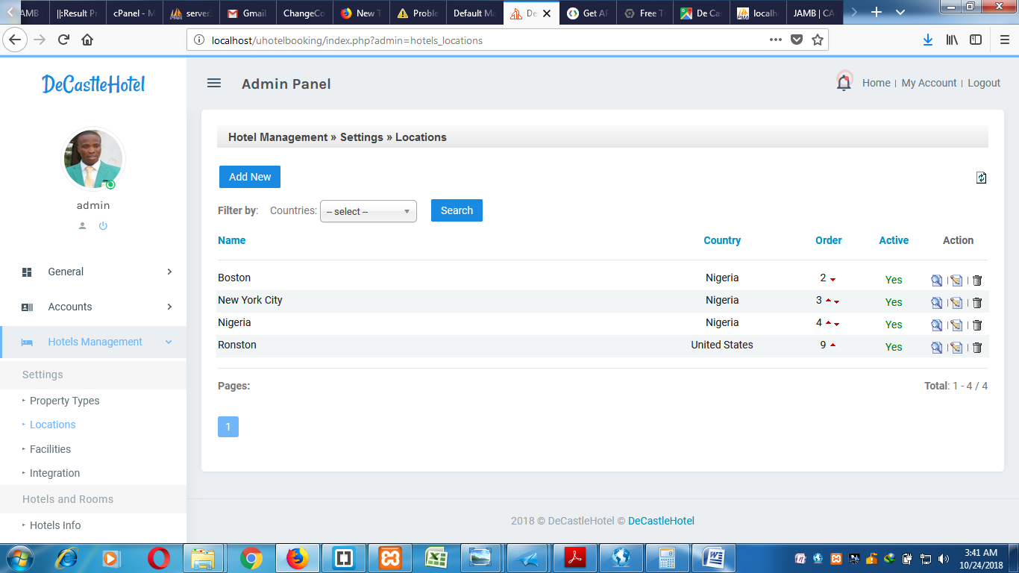

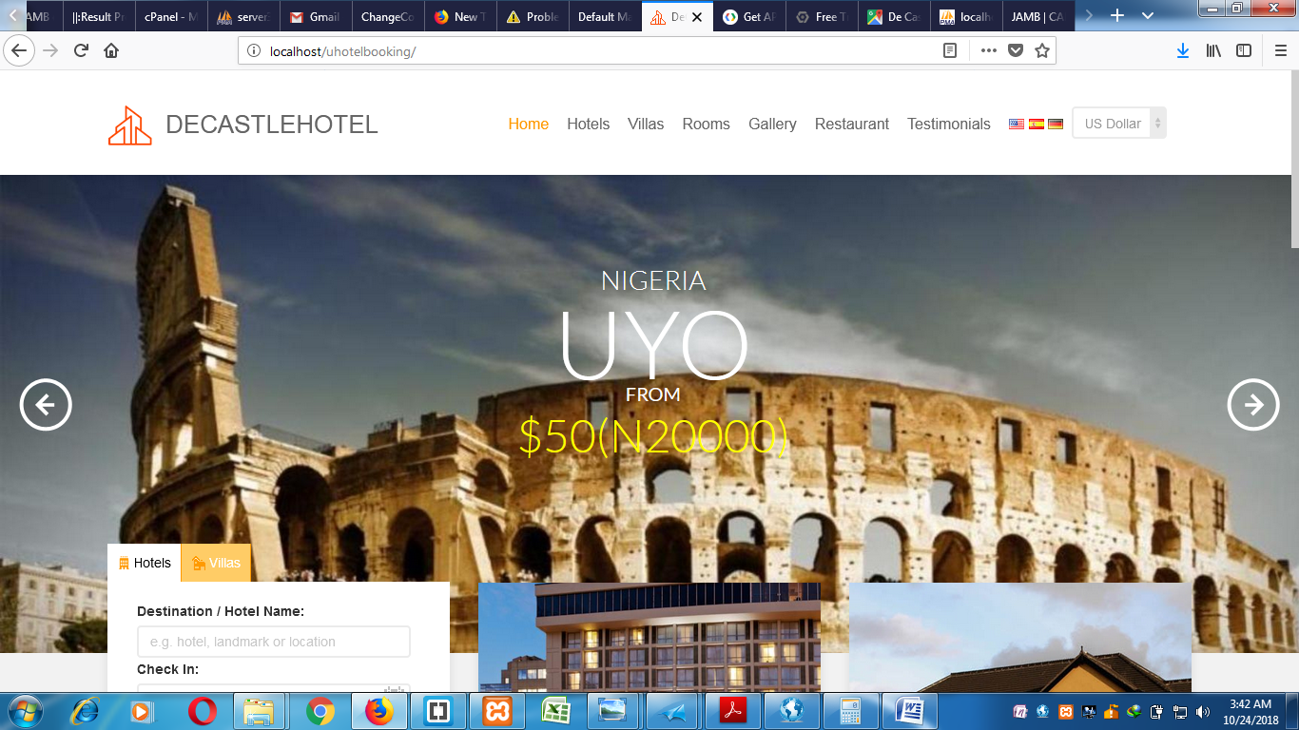



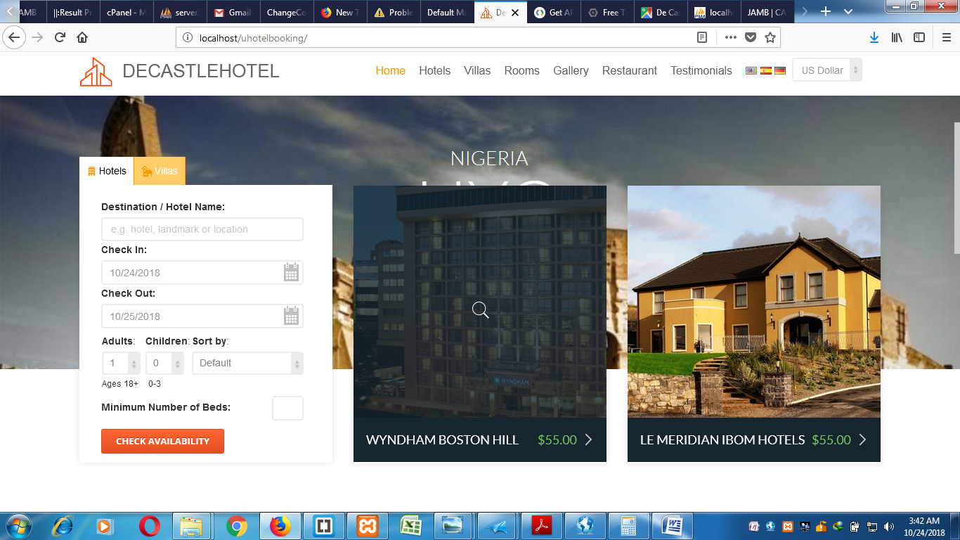

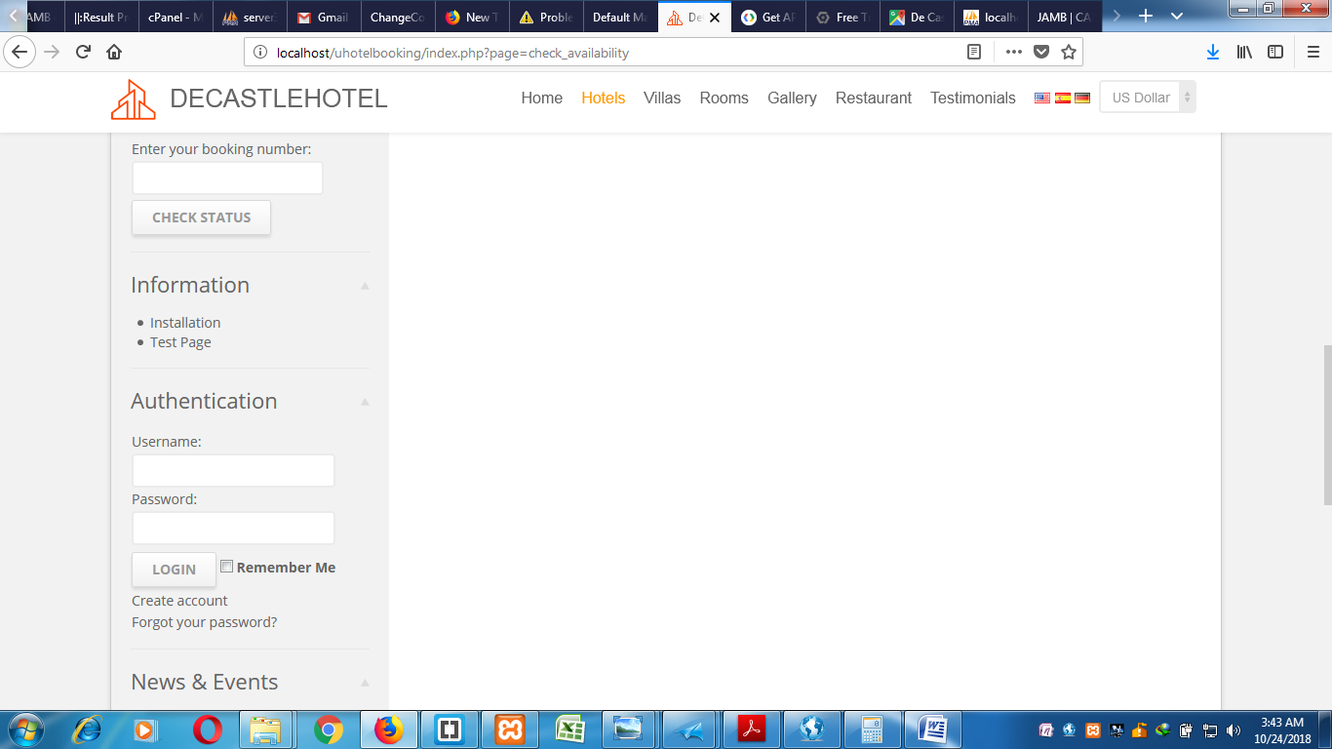

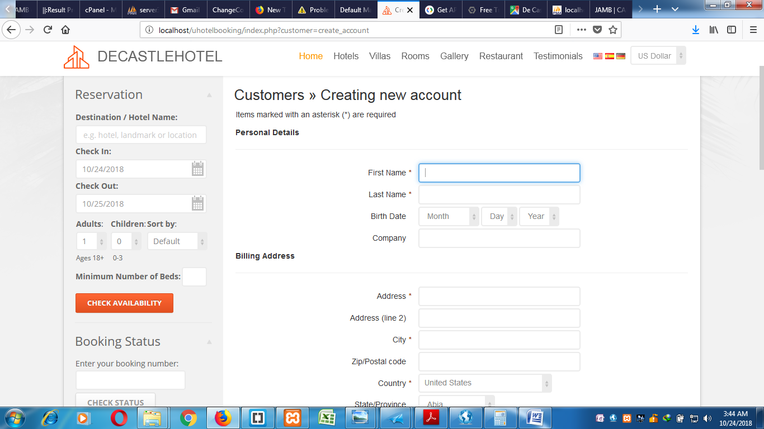

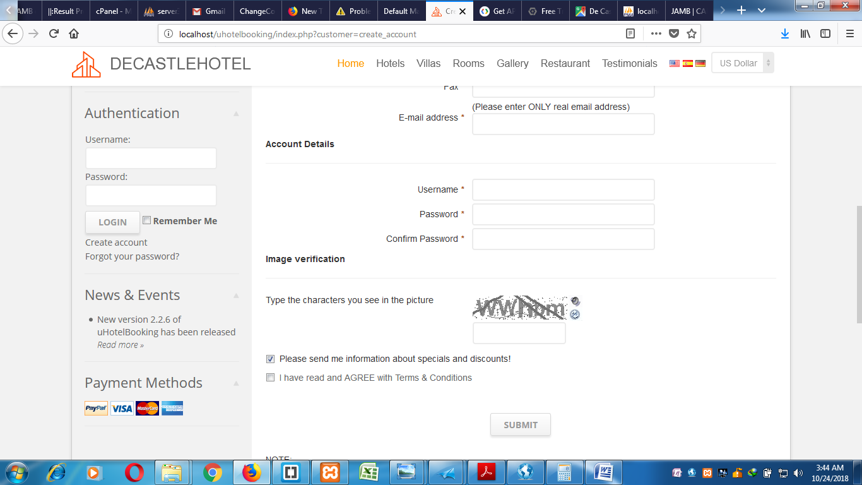

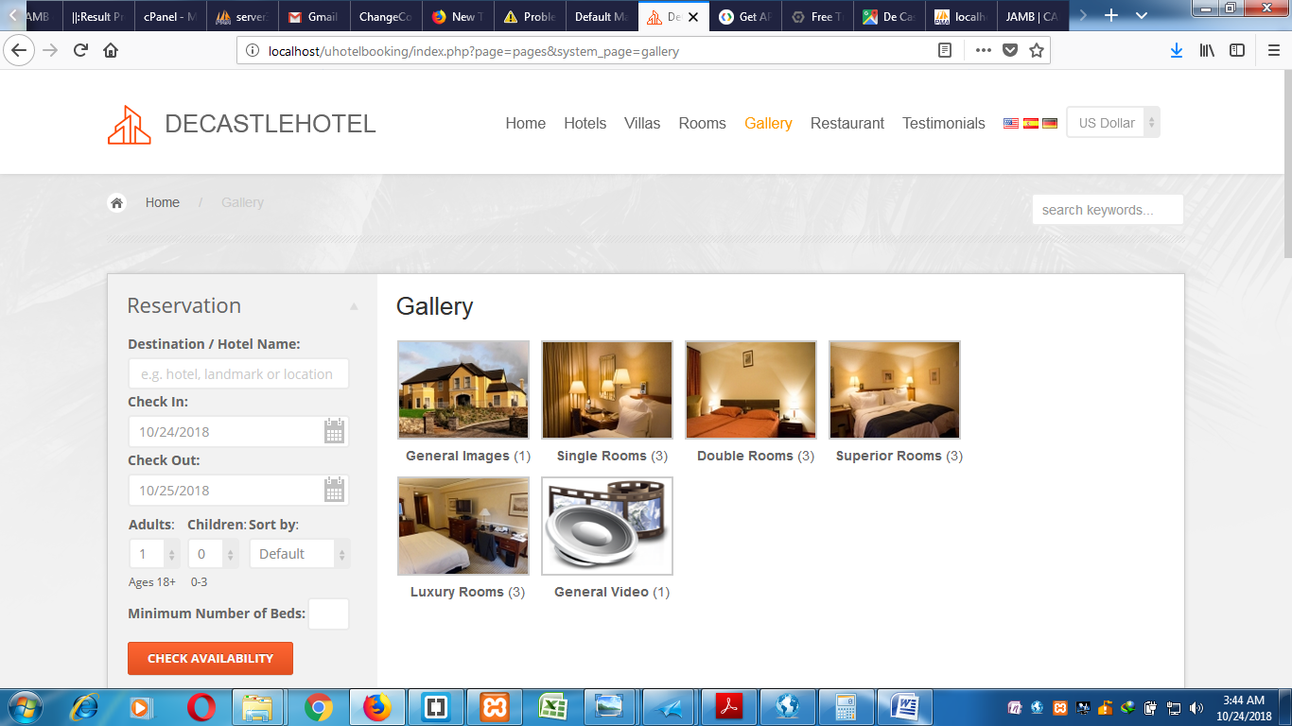

<?php

################################################################################

## -= YOU MAY NOT REMOVE OR CHANGE THIS NOTICE =- #

## --------------------------------------------------------------------------- #

## Developed by: AKPAN PEACE JOHNSON #

## Topic: Computer Based Hotel Management System (CBHMS)

## Case Study: De Castle Hotel, Uyo, Akwa Ibom State #

## Additional modules (embedded): #

## #

################################################################################

// *** Check if database connection parameters file exists

if(!file_exists('include/base.inc.php')){

}

## uncomment, if your want to prevent 'Web Page exired' message when use $submission_method = 'post';

//session_cache_limiter('private, must-revalidate');

// *** Set flag that this is a parent file

define('APPHP_EXEC', 'access allowed');

// *** Set CSRF validation

defined('CSRF_VALIDATION') or define('CSRF_VALIDATION', true);

// *** Set CSRF validation exclusions

// Ex.: 'key' => array('val1', 'val2')

// Ex.: array('admin' => array('login', 'my_account'), 'page' => array('faq', 'cms'))

// $CSRF_VALIDATION_EXCLUDE = array();

require_once('include/base.inc.php');

require_once('include/connection.php');

// *** Call handler if exists

// -----------------------------------------------------------------------------

if(Application::Get('page') != '' && file_exists('page/handlers/handler_'.Application::Get('page').'.php')){

include_once('page/handlers/handler_'.Application::Get('page').'.php');

}else if(preg_match('/check\_/i', Application::Get('page')) && !file_exists('page/handlers/handler_'.Application::Get('page').'.php')){

$page_types = explode('_', Application::Get('page'));

$page_type = isset($page_types[1]) ? $page_types[1] : '';

if(in_sub_array('property_code', $page_type, Application::Get('property_types'))){

include_once('page/handlers/handler_properties.php');

}

}else if((Application::Get('customer') != '') && file_exists('customer/handlers/handler_'.Application::Get('customer').'.php')){

if(Modules::IsModuleInstalled('customers')){

include_once('customer/handlers/handler_'.Application::Get('customer').'.php');

}

}else if((Application::Get('admin') != '') && file_exists('admin/handlers/handler_'.Application::Get('admin').'.php')){

include_once('admin/handlers/handler_'.Application::Get('admin').'.php');

}else if((Application::Get('admin') == 'export') && file_exists('admin/downloads/export.php')){

include_once('admin/downloads/export.php');

}

// *** Channel manager route

// -----------------------------------------------------------------------------

if(Modules::IsModuleInstalled('channel_manager') && (ModulesSettings::Get('channel_manager', 'is_active') != 'no')){

require_once('modules/additional/channel_manager/listener.php');

}

// *** Get site content

// -----------------------------------------------------------------------------

if(!preg_match('/(booking|cars)\_notify\_/i', str_replace('_', '\_', Application::Get('page')))){

$cachefile = '';

if($objSettings->GetParameter('caching_allowed') && !$objLogin->IsLoggedIn()){

$c_page = Application::Get('page');

$c_page_id = Application::Get('page_id');

$c_system_page = Application::Get('system_page');

$c_album_code = Application::Get('album_code');

$c_news_id = Application::Get('news_id');

$c_customer = Application::Get('customer');

$c_admin = Application::Get('admin');

if(($c_page == '' && $c_customer == '' && $c_admin == '') ||

($c_page == 'pages' && $c_page_id != '') ||

($c_page == 'news' && $c_news_id != '') ||

($c_page == 'gallery' && $c_album_code != '')

)

{

$cachefile = md5($c_page.'-'.

$c_page_id.'-'.

$c_system_page.'-'.

$c_album_code.'-'.

$c_news_id.'-'.

Application::Get('lang').'-'.

Application::Get('currency_code')).'.cch';

if($c_page == 'news' && $c_news_id != ''){

if(!News::CacheAllowed($c_news_id)) $cachefile = '';

}else{

$objTempPage = new Pages((($c_system_page != '') ? $c_system_page : $c_page_id));

if(!$objTempPage->CacheAllowed()) $cachefile = '';

}

if(start_caching($cachefile)) exit;

}

}

require_once('templates/'.Application::Get('template').'/default.php');

if($objSettings->GetParameter('caching_allowed') && !$objLogin->IsLoggedIn()) finish_caching($cachefile);

}

Application::DrawPreview();

<?php

// *** Make sure the file isn't accessed directly

defined('APPHP_EXEC') or die('Restricted Access');

//--------------------------------------------------------------------------

if($objLogin->IsLoggedInAs('owner','mainadmin')){

$action = MicroGrid::GetParameter('action');

$rid = MicroGrid::GetParameter('rid');

$mode = 'view';

$msg = '';

$objAdmins = new AdminsAccounts($objLogin->GetLoggedType(), 'site_admins');

if($action=='add'){

$mode = 'add';

}else if($action=='create'){

if($objAdmins->AddRecord()){

$msg = draw_success_message(_ADDING_OPERATION_COMPLETED, false);

$mode = 'view';

}else{

$msg = draw_important_message($objAdmins->error, false);

$mode = 'add';

}

}else if($action=='edit'){

$mode = 'edit';

}else if($action=='update'){

if($objAdmins->UpdateRecord($rid)){

$msg = draw_success_message(_UPDATING_OPERATION_COMPLETED, false);

$mode = 'view';

}else{

$msg = draw_important_message($objAdmins->error, false);

$mode = 'edit';

}

}else if($action=='delete'){

if($objAdmins->DeleteRecord($rid)){

$msg = draw_success_message(_DELETING_OPERATION_COMPLETED, false);

}else{

$msg = draw_important_message($objAdmins->error, false);

}

$mode = 'view';

}else if($action=='details'){

$mode = 'details';

}else if($action=='recreate_api'){

$msg = $objAdmins->RecreateApi($rid);

$mode = 'edit';

}else if($action=='cancel_add'){

$mode = 'view';

}else if($action=='cancel_edit'){

$mode = 'view';

}

// Start main content

draw_title_bar(prepare_breadcrumbs(array(_ACCOUNTS=>'',_ADMINS_MANAGEMENT=>'',_ADMINS=>'',ucfirst($action)=>'')));

//if($objSession->IsMessage('notice')) echo $objSession->GetMessage('notice');

echo $msg;